# MongoDB Assignment [Deadline: 2025-09-01]

Database Name: user

Collection Name: users

### Data:

[

{

username: "alex_p",

email: "alex.p@example.com",

age: 28,

country: "USA",

last_login: ISODate("2023-10-25T10:00:00Z"),

followers: 1200,

interests: ["programming", "hiking", "music"],

profile: { theme: "dark", bio: "Software developer and nature enthusiast." },

devices: [

{ type: "mobile", os: "Android", last_seen: ISODate("2023-10-25T09:55:00Z") },

{ type: "desktop", os: "Windows", last_seen: ISODate("2023-10-24T15:30:00Z") }

]

},

{

username: "jane_doe",

email: "jane.d@workplace.com",

age: 34,

country: "Canada",

last_login: ISODate("2023-11-01T12:30:00Z"),

followers: 850,

interests: ["travel", "photography", "music"],

profile: { theme: "light" },

subscription: { tier: "premium", start_date: ISODate("2023-01-01T00:00:00Z") }

},

{

username: "sam_g",

email: "sam.g@example.com",

age: 22,

country: "UK",

last_login: ISODate("2023-09-15T18:45:00Z"),

followers: 2500,

interests: ["gaming", "streaming"],

profile: { theme: "dark", bio: "Pro gamer and streamer." },

devices: [

{ type: "desktop", os: "Windows", last_seen: ISODate("2023-09-15T18:40:00Z") }

]

},

{

username: "chris_b",

email: "chris.b@inbox.com",

age: 45,

country: "Australia",

last_login: ISODate("2023-10-30T05:00:00Z"),

followers: 50,

interests: ["gardening", "cooking"],

profile: { theme: "light", bio: "Loves the outdoors." }

},

{

username: "maria_s",

email: "maria.s@example.com",

age: 31,

country: "Germany",

last_login: ISODate("2023-11-02T20:00:00Z"),

followers: 1800,

interests: ["art", "history", "travel"],

profile: { theme: "dark", bio: "Museum curator." },

subscription: { tier: "premium", start_date: ISODate("2022-06-15T00:00:00Z") }

},

{

username: "another_user",

email: "another@example.com",

age: 29,

country: "USA",

followers: 95,

interests: ["music", "programming"],

profile: "Profile setup pending"

}

]

### **Write queries for the given questions**

1. Find users older than 30, but only show their username and country.

1. Find users whose follower count is less than or equal to 100.

Ans: 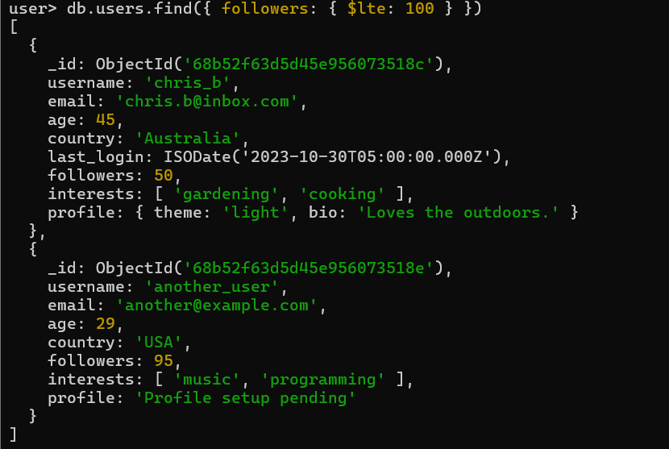

1. Find all users from 'USA' or 'Canada'.

1. Find all users who are NOT from 'USA' or the 'UK'.

1. Find users who are from the 'USA' AND have more than 1000 followers.

1. Find users who have more than 2000 followers OR are from 'Australia'.

Ans: 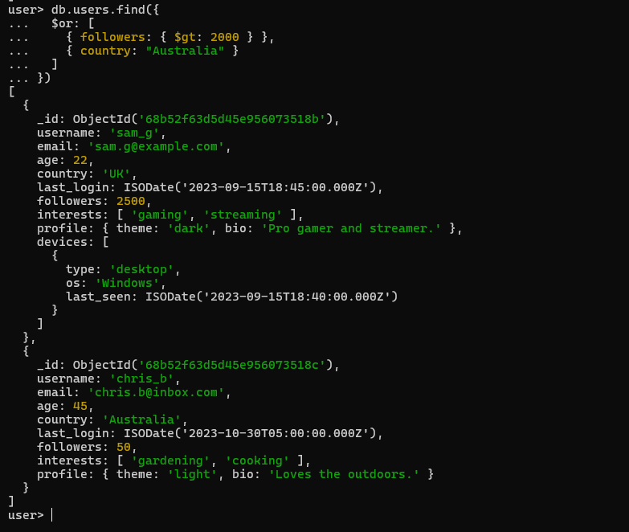

1. Find all users who have a subscription field.

1. Find users whose profile field is a string, not an embedded document.

1. Find users who are interested in both 'travel' AND 'music'.

1. Find users who have used a 'mobile' device since October 1st, 2023.

1. Find all users whose email address ends with '[**workplace.com**](http://workplace.com)'.

1. For user sam_g, add 50 followers and add a new interest 'coding'.

1. For all users from the 'USA', rename the followers field to follower_count.

1. Attempt to update user new_user; if they don't exist, insert them with default data.

1. Delete all users who have not logged in (*hint: the last_login field does not exist*).

Ans : 

1. Find users from the 'USA' who are either younger than 25 OR have more than 1500 followers.

1. Find all users who have a 'desktop' device that runs 'Windows'.

1. Update all users with a 'dark' theme profile by adding a pro_user: true flag.

